**TeleMental Health Sessions using TAO Videoconferencing:**

At this time the Video Conference option is not available through the phone app. You can access the videoconferencing feature from your desktop, laptop, iPad/tablet, or phone through a web-browser. You will have to able to log into the internet in order to use the TAO video/audio conference feature. If you do not have internet available please let your provider know as soon as possible. You can access TAO Videoconferencing by logging to the following address and taking the steps below: <http://thepath.taoconnect.org>

You will have to log in through the full web address, listed below, in order to access the video conference application. You can complete your survey assessments, module sessions, logs, and mindfulness library through the phone app.

Prior to your appointment you will have to complete the appropriate CAPS Paperwork (e.g. CCAPS, consent forms and student questionnaire) through the Student Health and Counseling Portal (<https://chconline.ucr.edu/>) for your clinician’s review prior to your session. Once you login to TAO your will have to complete the Warwick-Edinburgh Mental Well-Being Scale prior to each appointment.

How to Access TAO Videoconferencing.

1. Your assigned provider will enter your name and UCR email into the TAO online platform which will generate an email that will be sent to you stating that a new account has been created for you**. In this email it will tell you your username (which is your UCR email address) and a temporary password. Follow the prompts to create a profile and reset your password to one of your choosing. **If you do not see the email** in your inbox please check you spam/trash folder as it sometimes automatically goes there.

**If you have already created a self-help profile within TAO please follow these steps.

If you have already created a self-help account on your own please log in with your normal username and password.

You will then be prompted to “select a group”, which is the name of the clinician you have an appointment with.

**In order to access the videoconferencing feature to speak with your provider you will have to select the provider name as the selected group. See images below**

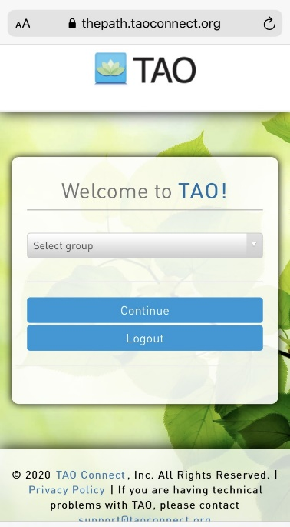 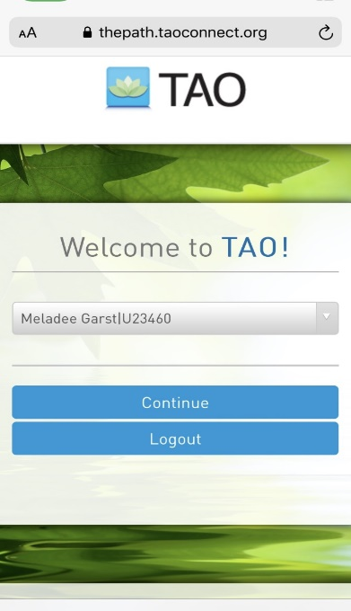

1. Once you get to the front page at the top you will see in the blue banner the words “Video Conference”. If you are using a device outside of a desktop or laptop use the menu button on the upper left hand side of your device and select videoconferencing. 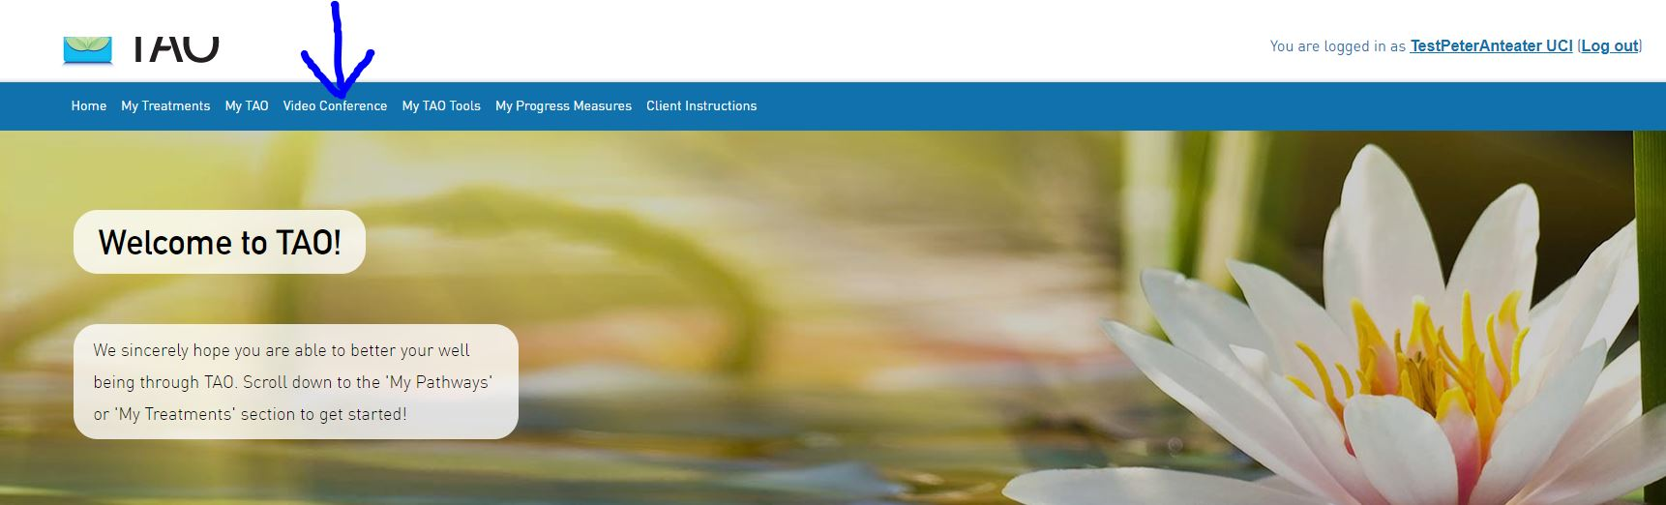
2. Once you click the “video conference” button you will be redirected to a new page that looks like the following. Once here you will hit button that says “Start Video Conference with “(your therapist name)”. Videoconferencing sessions are available through a HIPAA compatible Zoom Account.

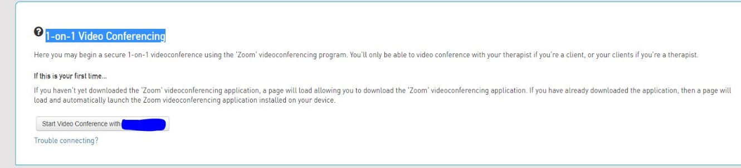

*NOTE: If you have never downloaded Zoom on the device you are using you will see a prompt to download the Zoom program before the meeting can launch. If you are using --a smart phone, IPad, or tablet you will have to download the Zoom app. Prior to your appointment, please make sure you have downloaded the Zoom application; and that you have enabled the microphone and videocamera on the device you are using.*

*\*\*If you do not feel comfortable with videoconferencing sessions please speak to your provider to determine alternative options such as audio only, within the TAO platform, or determine if phone sessions are most appropriate.*

1. Once the video conference session has ended you will close the zoom meeting window.
2. Your therapist will not be available to video conference unless an appointment is scheduled and they have opened the application. Please note that if you click on the video conferencing option when you do not have an appointment scheduled no one will pick up on the other end.

Resources: If you feel you are in need of emergency services please call CAPS at 951-827-5531 and select option “1” (or by calling the direct line at 877-211-3684). Call the National Suicide Prevention Lifeline at 1-800-273-8255 or . You can always call 911 or go to the nearest emergency room.

*Adapted courtesy of UC Irvine Counseling Center*